**PRODUCT SALES SQL QUERIES**

**KPI’s**

**1. Total Revenue:**

SELECT SUM(Total_price) AS total revenue FROM Sales_record;

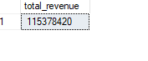

**2. Average Order Value**

SELECT SUM(Total_price) / COUNT(distinct order_id) AS Avg_order_value

FROM sales_record;

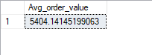

**3. Total Quantity sold**

SELECT SUM(quantity_sold) AS SUM_quantity_sold FROM sales_record



**Total Quantity sold by Product Category**

SELECT SUM(quantity_sold) FROM sales_record WHERE product_category = 'Food'

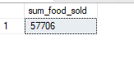

SELECT SUM(quantity_sold) FROM sales_record WHERE product_category = 'Clothing'

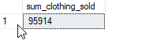

SELECT SUM(quantity_sold) FROM sales_record WHERE product_category = 'Electronics'

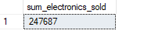

**4. Total Orders**

SELECT COUNT(distinct order_id) AS total_orders FROM sales_record;

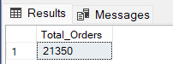

**5. Average Product Per Order**

SELECT CAST (SUM(quantity_sold) AS decimal(10,2))/ CAST (COUNT(distinct order_id)AS decimal(10,2)) AS avg_order_per_product

FROM sales_record;



**B. Daily Trend for Total Orders**SELECT DATENAME(DW, order_date) AS order_day, COUNT(distinct order_id) AS total_orders

FROM sales_record

GROUP BY DATENAME(DW, order_date);

***Output:***

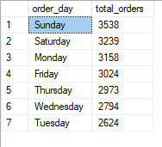

**C. Monthly Trend for Total Orders**

SELECT DATENAME(MONTH, order_date) AS order_month, COUNT(distinct order_id) AS total_orders

FROM sales_record

GROUP BY DATENAME(MONTH, order_date)

ORDER BY total_orders DESC;

***Output***

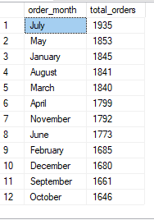

**D. Percentage of Sales by Product Category**

SELECT product_category, SUM(total_price) AS total_sales, SUM(total_price)* 100/ (SELECT SUM(Total_price) FROM sales_record) AS pct_total_sales

FROM sales_record

GROUP BY product_category

ORDER BY pct_total_sales;

***Output***

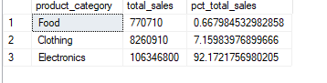

**E. Percentage of Sales by Product Name**

SELECT product_name, SUM(total_price) AS total_sales, SUM(total_price)* 100/ (SELECT SUM(Total_price) FROM sales_record) AS pct_total_sales

FROM sales_record

GROUP BY product_name

ORDER BY pct_total_sales;

***Output***

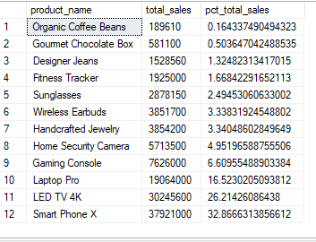

**F. Total Product Sold by Product Category**

SELECT product_category, SUM(quantity_sold) AS total_quantity_sold

FROM sales_record

GROUP BY product_category

ORDER BY total_quantity_sold;

***Output***

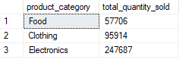

**G. Top 5 Product by Revenue**

SELECT Top 5 product_name, SUM(total_price) AS total_revenue

FROM sales_record

GROUP BY product_name

ORDER BY total_revenue DESC;

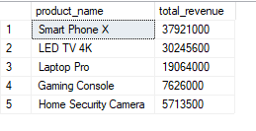

**H. Bottom 5 Product by Revenue**

SELECT Top 5 product_name, SUM(total_price) AS total_revenue

FROM sales_record

GROUP BY product_name

ORDER BY total_revenue ASC;

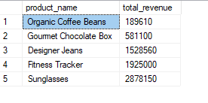

**I. Top 5 Product by Quantity**

SELECT Top 5 product_name, SUM(quantity_sold) AS total_quantity_sold

FROM sales_record

GROUP BY product_name

ORDER BY quantity_sold DESC;

***Output***

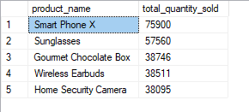

**J. Bottom 5 Product by Quantity**

SELECT Top 5 product_name, SUM(quantity_sold) AS total_quantity_sold

FROM sales_record

GROUP BY product_name

ORDER BY total_quantity_sold ASC;

***Output***

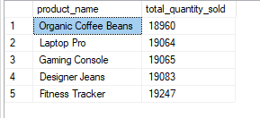

**K. Top 5 Product by Total Orders**

SELECT Top 5 product_name, COUNT(distinct order_id) AS total_orders

FROM sales_record

GROUP BY product_name

ORDER BY total_orders DESC;

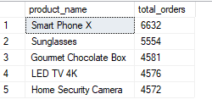

**L. Bottom 5 Product by Total Orders**

SELECT Top 5 product_name, COUNT(distinct order_id) AS total_orders

FROM sales_record

GROUP BY product_name

ORDER BY total_orders ASC;

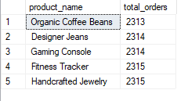

**M. Payment method by Total Orders**

SELECT payment_method, COUNT(distinct order_id) AS total_orders

FROM sales_record

GROUP BY payment_method

ORDER BY total_orders DESC;

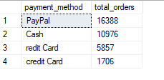

**N. Location by Total Orders**

SELECT location, COUNT(distinct order_id) AS total_orders

FROM sales_record

GROUP BY location

ORDER BY total_orders DESC;

